LAB 9
2019F_ESE 3014_1

GROUP 16 -

FRANCIS VIJITH A J– C0742980
VIJAYAPRAKASH V I – C0744450

Set up and achieve SPI interfacing communication for BBB as master andADXL345 Accelerometer as slave.

Checking the BB-SPI.dtbo files.
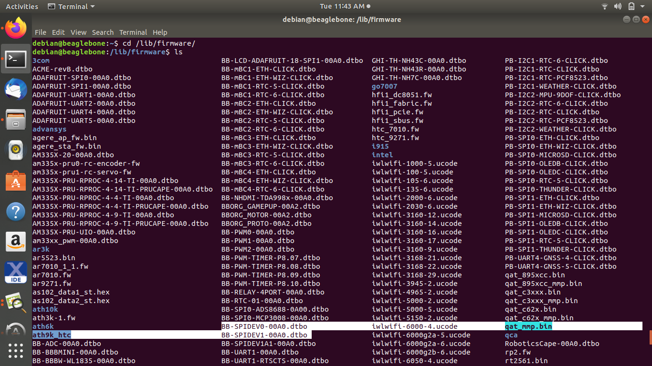
Editing the uEnv.txt file in /boot in nano editor to enable the SPI pin configuration

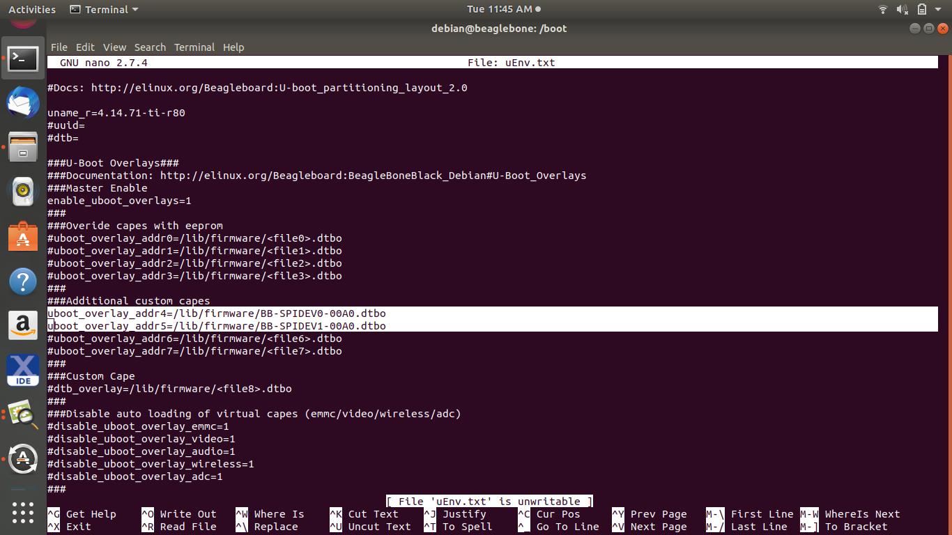
Checking for SPI pins
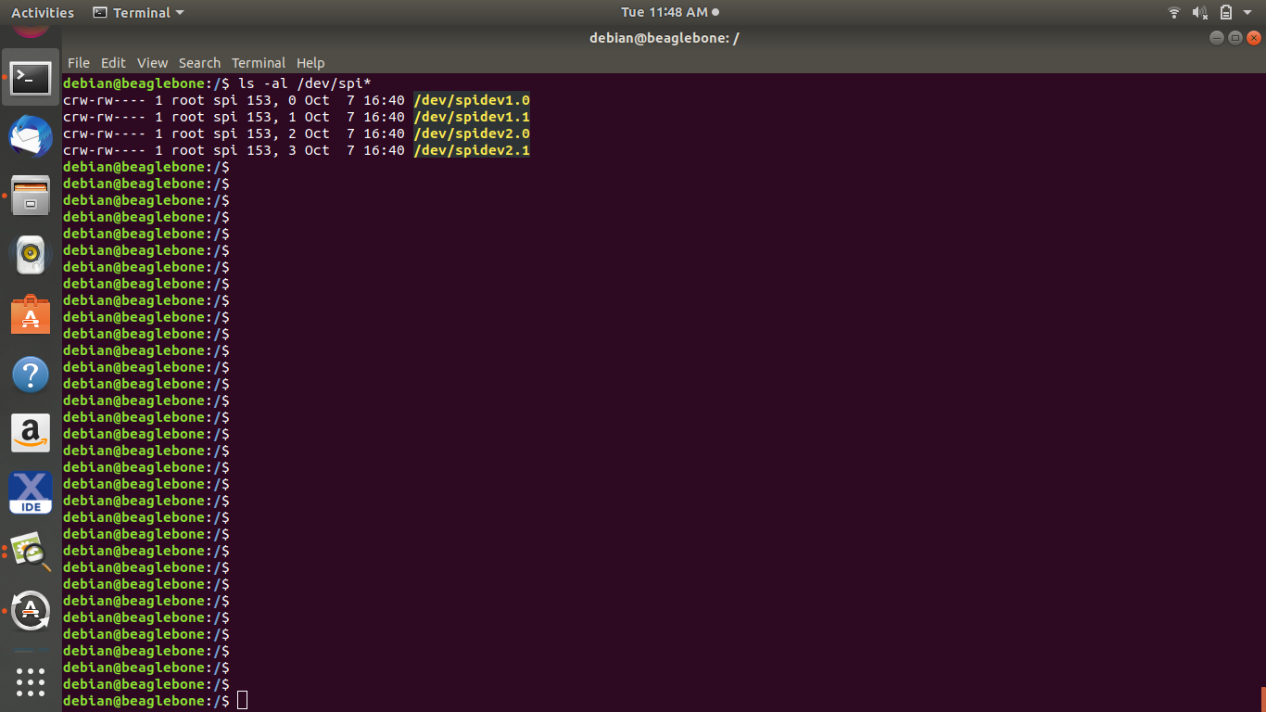
Testing the SPI pins with a c program SPIdev_test and changing the position of the accelerometer
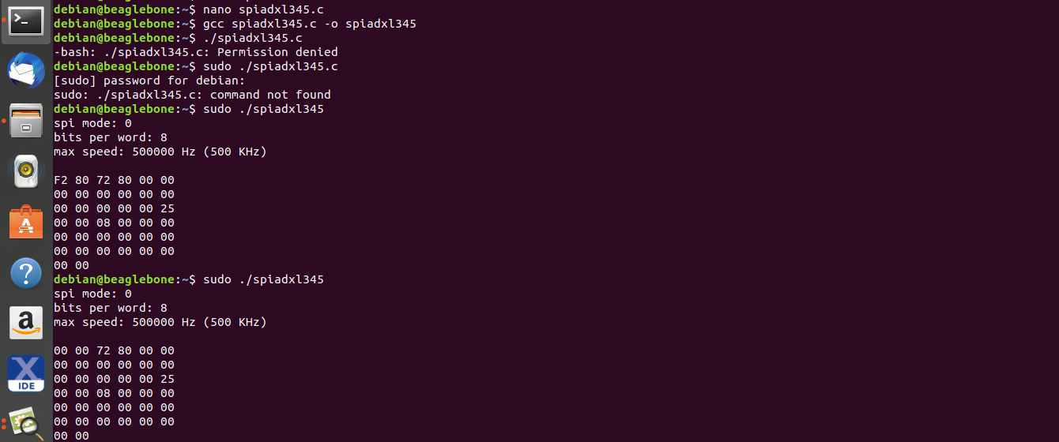
There is a change in values returned when spiadxl345.c is executed.

